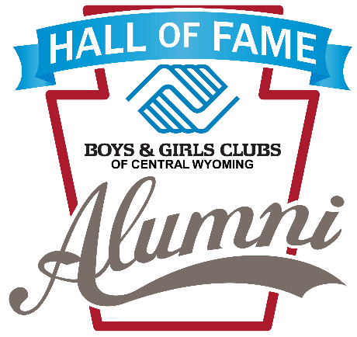
Boys & Girls Clubs of Central Wyoming
Alumni Hall of Fame – 2024 Nomination Form

Nominate your candidate for consideration to be inducted into the Boys & Girls Clubs of Central Wyoming Alumni Hall of Fame. Nominees may demonstrate exceptional service and commitment in their professional, philanthropic, civic, or educational activities in support of their community.

Nominees are great role models for Club members and are former Club members of any of the current or past Boys & Girls Clubs of Central Wyoming Branches including all of the Casper sites, Buffalo, Dubois, Glenrock, Riverton or Shoshoni. Nominees must be at least 30 years of age to qualify for the Hall of Fame.

Please indicate your nominee and complete the questions, on the reverse, in as much detail as possible. Use additional pages and/or include attachments if needed.

The nomination deadline is July 1, 2024. Submit nominations to Ashley Bright at abright@bgccw.org.

Nominee’s Name:_________________________________________________________________________

Nominee’s Former Boys & Girls Club Branch:_________________________________________________

Nominee’s Email Address:__________________________________________________________________

Nominee’s Phone Number:_________________________________________________________________

Nominator’s Name:________________________________________________________________________

Nominator’s Former Boys & Girls Club Branch (If Applicable):__________________________________

Nominator’s Email Address:________________________________________________________________

Nominators’ Phone Number:________________________________________________________________
Nominee’s background and accomplishments:

What has this person done to make a difference in their community?

Please describe this person’s service to the community regarding our community youth, (and to the Boys & Girls Clubs, if appropriate):

Why is this person being nominated to be inducted into the Boys & Girls Clubs of Central Wyoming Alumni Hall of Fame (1-2 paragraphs)?

